**DBMS Mini Project Report on**

**“Library Management System”**

**Submitted By**

Rajat Belgundi ERP 1032180203

Kartik Bhutada ERP 1032180229

Amey Bhide ERP 1032180301

Divyang Bagla ERP 1032180739

**Under the Guidance of**

**PROF. Pradnya Kulkarni**

At



**Contents**

Abstract……………………………………………………………………………………….3

1. Introduction ……………………………………………………………………………………4
   1. Motivation ………………………………………………………………………………….
   2. Objectives ………………………………………………………………………………….
2. Problem Definition …………………………………………………………………………….5
   1. Problem Statement………………………………………………………………………..
   2. Tools and Technologies Used ……………………………………………………………
3. Database Design (ER Diagram) ………………………………………………………………..6
4. Database Schema………………………………………………………………………………..7
5. Relational Database Design …………………………………………………………………….8
6. Normalization …………………………………………………………………………………...9
7. SQL Commands Used …………………………………………………………………………..10
   1. DDL …………………………………………………………………………………………10
   2. DML………………………………………………………………………………………….12
   3. DCL ………………………………………………………………………………………….15
   4. Triggers ………………………………………………………………………………………16
   5. Functions & Procedures ……………………………………………………………………...17
8. Frontend GUI …………………………………………………………………………………….18
9. Conclusion ………………………………………………………………………………………..21
10. References ………………………………………………………………………………………...22

**Abstract**

Library management system is a project which aims in developing a computerized system to help perform daily work of the library. This application provides the facility of user and librarian login. Librarian can keep a track of the details of books issued and returned by the user. This project is developed in java which mainly focuses on basic operations in library like addition of new members, books, updating user information, searching books and members and facility to borrow and return book.

The Library Management System provides exact information about the number of books that are taken by the users, the number of books that are left, date of issue etc and it even calculates the fine automatically, thereby reducing the risk present in the manual management of libraries.

Overall this project is being developed to help the users and library staff to maintain the library in the best way possible and also reduce the human efforts.

**Chapter -1**

**Introduction**

* 1. **Motivation :**

Few reasons to select this project of Library Management System :-

* Library is an essential part of society as a whole.
* To overcome flaws in manual library management.
* To facilitate quick and efficient searching of books.
* To establish a systematic, neat and well organised library.
  1. **Objectives:**

The main aims and objectives are:

* To have an efficient book issue and return facility.
* To provide information regarding authors and publishers.
* To display the late return and penalty information to the user.
* To facilitate easy addition and deletion of books to the Librarian.
* To provide monitoring of members to the Librarian.

**Chapter -2**

**Problem Definition**

**2.1 Problem Statement:**

The library management system is a software developed for monitoring and controlling the transactions in the library. The system maintains the record of books available in the library. It mainly focuses on adding new members, books, author and publisher details. The system also facilitates easy searching, issuing and returning of books. The system also shows the borrow details like lend date, return date, penalty / fine. The system also provides the facility to search for books based on authors and publishers as well. The system also provides the facility to monitor the members of the library.

The librarian details involve librarian id, name, password, email, contact details, address (street, city, zipcode). The member details involve member id, name, password, email, contact details, address (street, city, zipcode). The book details involve book id, name, aisle, genre. The author details involve author id, name, email. The Publisher details involve Publisher id, name, email. The contact details of librarian and members are assumed to be single valued.

A member can issue a single book at a time. One author can write many books. One publisher can publish many books. A librarian can add / delete more than one books.

**2.2 Tools and Technologies Used:**

* MySQL Shell
* MySQL Workbench
* Eclipse IDE for Java Developers
* JDK
* JDBC
* Java Swing

**Chapter – 3**

**Database Design (Entity Relationship Diagram)**

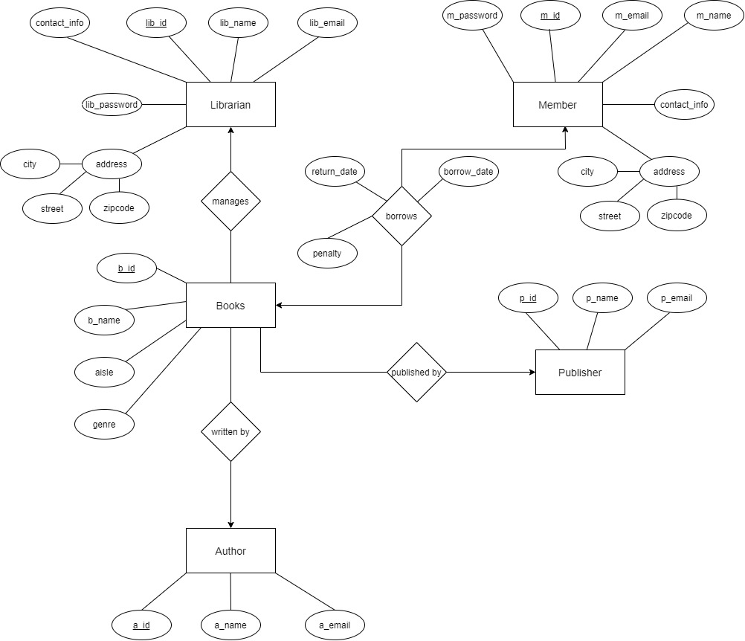

**Chapter - 4**

**Database Schema**

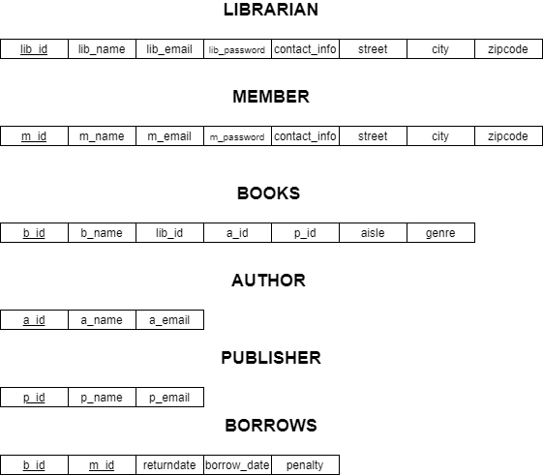

**Chapter – 5**

**Relational Database Design (Schema Diagram)**

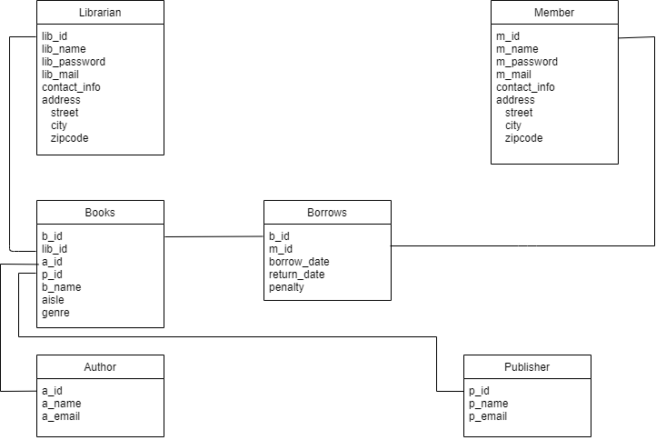

**Chapter – 6**

**Normalization**

**Primary Keys :-**

Librarian(lib_id)

Member(m_id)

Books(b_id)

Author(a_id)

Publisher(p_id)

Borrows(b_id,m_id) – Composite primary keys

**1st Normal Form :-**

1st NF is concerned with multivalued attributes.

In this case, the entities do not have any multi valued attributes.

**2nd Normal Form :-**

For the tables to be in 2nd NF the non key attributes of the table should not be partially dependent on any single element of composite primary key.

In this case, borrows table has composite primary key (b_id, m_id)

All the attributes are dependent on composite primary key so, there is no partial dependency in this case.

**3rd Normal Form :-**

For the table to be in 3rd NF the non key attributes shouldn’t have the transitive dependency on the primary key.

In this case, the entities do not have any transitive dependencies.

**Chapter 7**

**SQL Commands Used**

**7.1 DDL**

Create Database

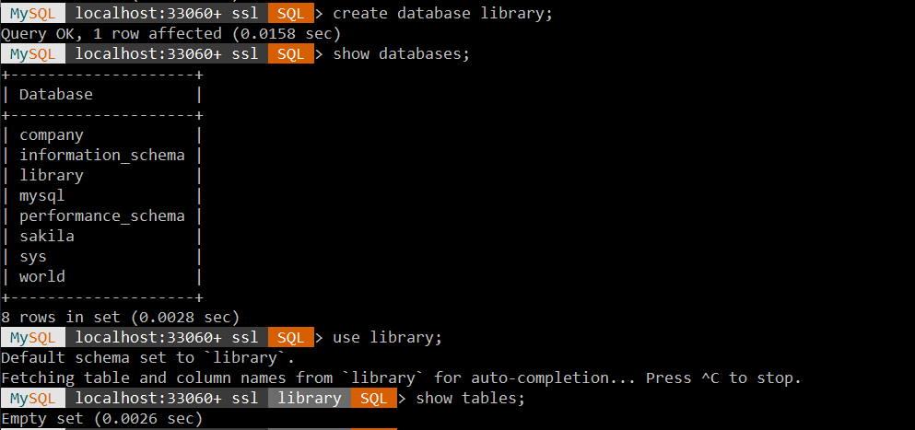

Create Table Librarian

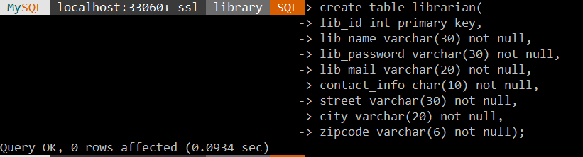

Create Table Member

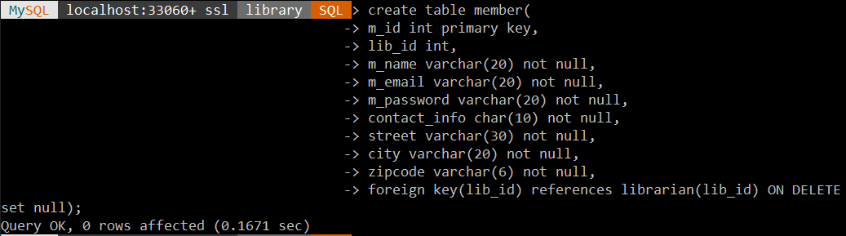

Create Table books

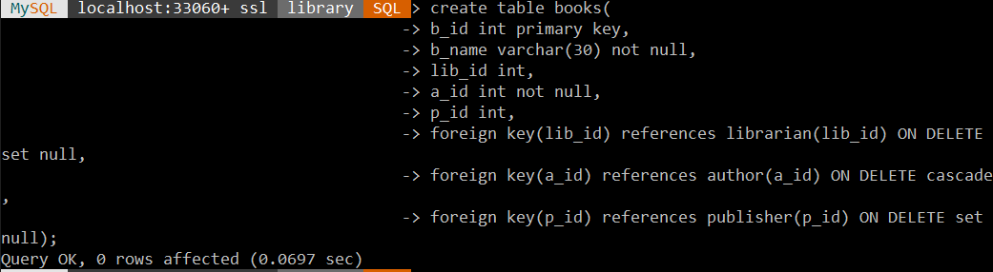

Create Table borrows

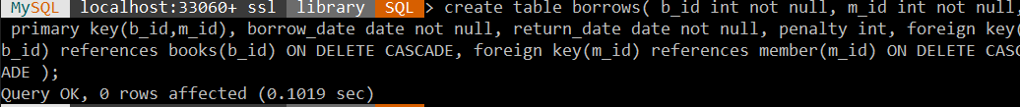

Create Table author

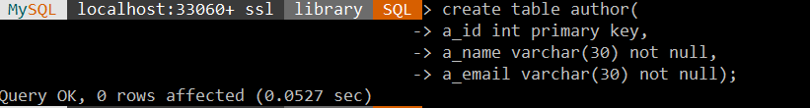

Create Table Pubisher

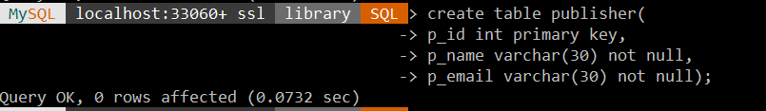

**7.2 DML**

Librarian Table

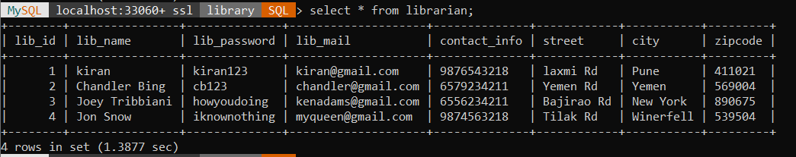

Member Table

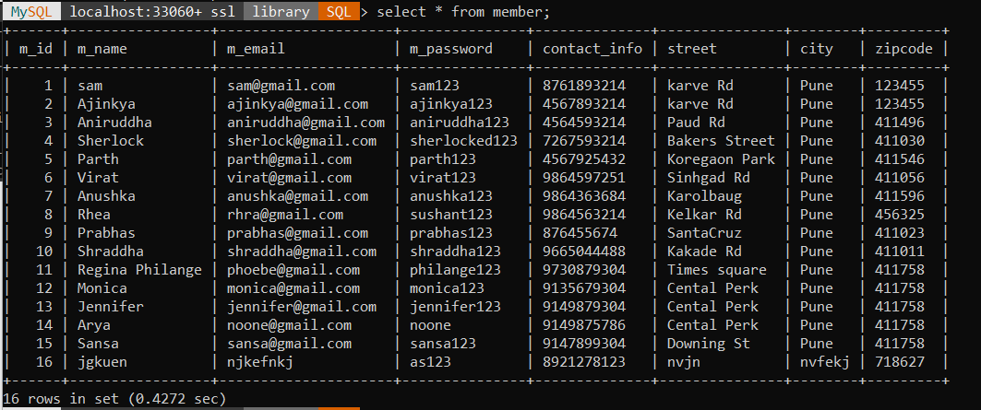

Books Table

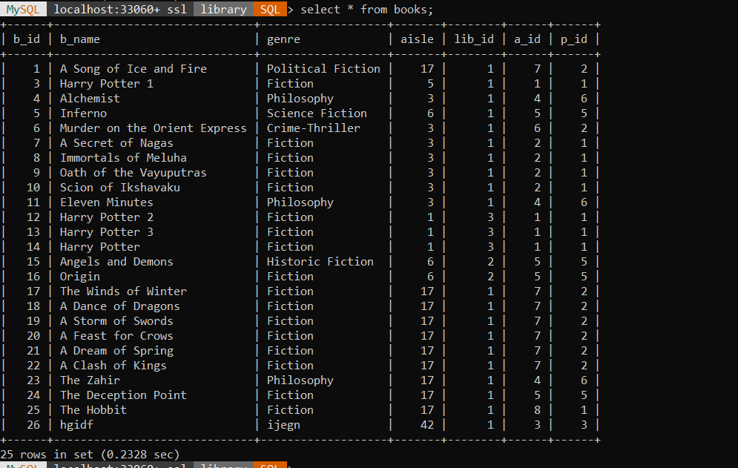

Borrows Table

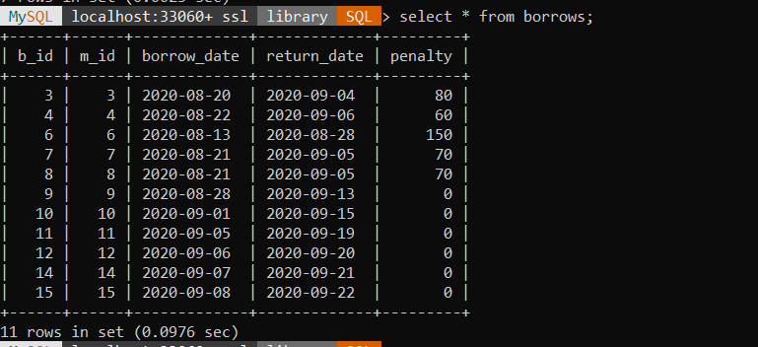

Author Table

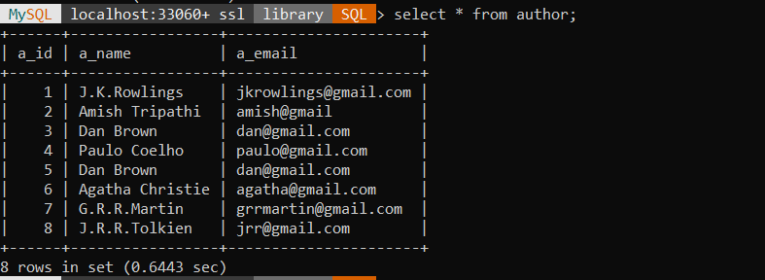

Publisher Table

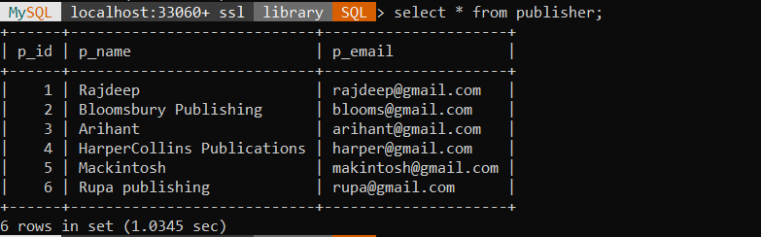

**7.3 DCL**

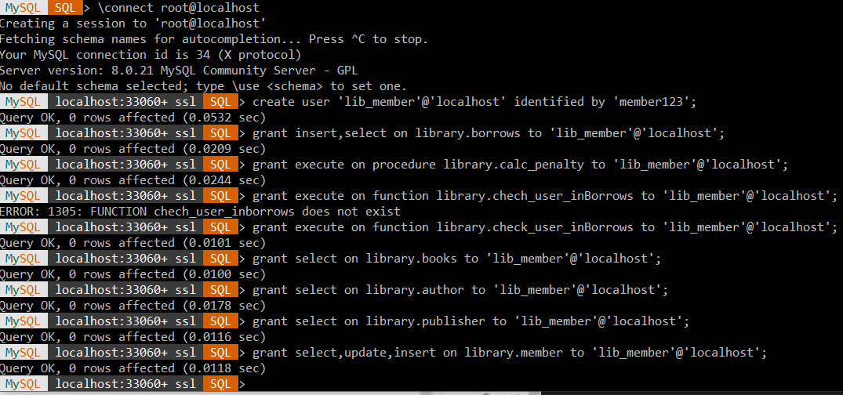

**7.4 Triggers**

delimiter $$

create trigger history

after delete on borrows

for each row

BEGIN

insert into history values(OLD.m_id,OLD.b_id,OLD.borrow_date,curdate());

END $$

**7.5 Procedures & Functions**

**Procedure**

delimiter $$

create procedure calc_penalty(IN mem_id int)

BEGIN

declare r_date date;

declare diff_days int;

set r_date = (select return_date from borrows where m_id=mem_id);

set diff_days = DATEDIFF(curdate(),r_date);

if(diff_days > 0) then

UPDATE borrows

set penalty=diff_days*10

WHERE m_id=mem_id;

end if;

END $$

**Function**

delimiter $$

create function check_user_inBorrows(mem_id int)

returns int

DETERMINISTIC

BEGIN

declare mem_check int default 0;

set mem_check = (select m_id from borrows where m_id=mem_id);

if(mem_check != 0) then

return 1;

else

return 0;

end if;

END $$

**Chapter – 8**

**Frontend GUI**

**Welcome Window**

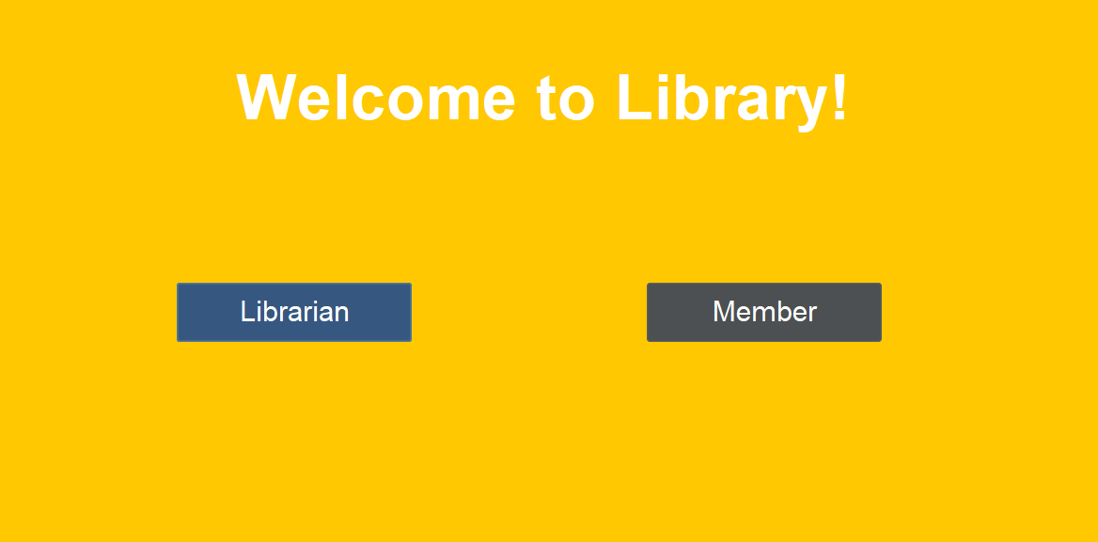

**Librarian Login**

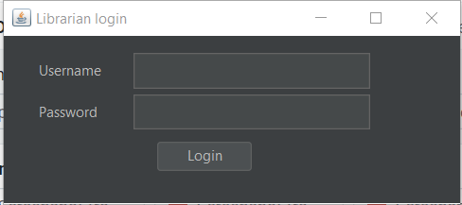

**Member Login & Registration**

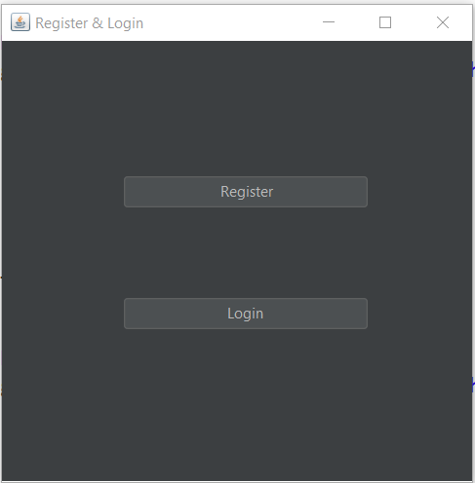

**Librarian Functions**

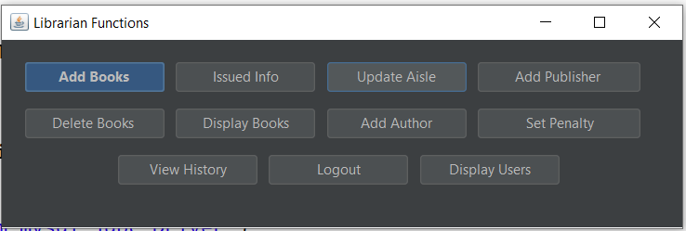

**Member Functions**

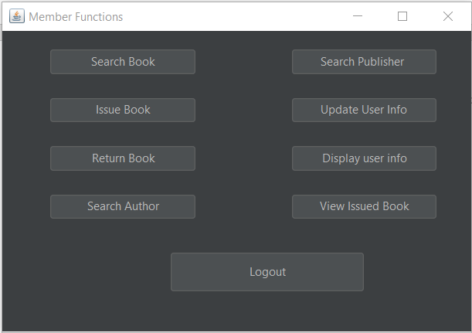

**Chapter 9**

**Conclusion**

The implemented system automates the tasks involved in managing the library in a efficient way. The system is user friendly and also librarian friendly. The system provides author and publisher information for the avid readers. This system also provides easy tracking of members which makes it easier for the librarian to manage and control the transactions of the library. For the digital world where everything works through mobile and computers, this system is the perfect replacement for the traditional library management system.

**Source Code:-** [**https://github.com/bagladivyang03/Library-Management-System**](https://github.com/bagladivyang03/Library-Management-System)

**References**

[S. Kappagantula](https://www.edureka.co/blog/author/sahiti-kappagantulaedureka-co/) **“How To Create Library Management System Project in Java?”** [**https://www.edureka.co/blog/library-management-system-project-in-java**](https://www.edureka.co/blog/library-management-system-project-in-java)(5-sept-2020)

[Prabhakar](https://www.edureka.co/blog/author/sahiti-kappagantulaedureka-co/) Gupta **“Library Management System ”** [**https://github.com/prabhakar267/library-management-system**](https://github.com/prabhakar267/library-management-system)(6-sept-2020)

[Open](https://www.edureka.co/blog/author/sahiti-kappagantulaedureka-co/) Source Contribution **“Library Management System JAVA**[**” https://github.com/OSSpk/Library-Management-System-JAVA**](”%20https:/github.com/OSSpk/Library-Management-System-JAVA)(8-sept-2020)